Christa Noel Robbins

Krauss, Rosalind Epstein (1941- ) 541 Words

Born and raised in Washington, D.C., Rosalind Krauss is an art historian, critic and theorist whose writing is focused on modern and contemporary art. First introduced to modernist art through the art collections that populate D.C., Krauss went on to earn her bachelors in art history at Wellesley College, before earning a doctorate in the field at Harvard University (1963-1969). Krauss’s doctoral thesis, which addressed the modernist sculptures of David Smith, was published under the title *Terminal Iron Works* in 1971, and remains one the most influential accounts of the sculptor’s work. It was at Harvard that she first met Michael Fried and through Fried, Clement Greenberg. It was within their spheres of influence that she began to publish art criticism in journals such as *Arts Magazine* and *Artforum* while still in graduate school. In the early seventies, Krauss broke publicly with the formalist criticism then being advanced by Greenberg and Fried. She has since become known for her advocacy and advancement of poststructuralist interpretations of art, most notably in her editorial work for the journal *October*, which she co-founded in 1976.

Krauss began her career in art criticism as a self-described formalist, publishing mainly on late-modernist artists who were also promoted by Greenberg and Fried, such as Morris Louis, Jules Olitski, Kenneth Noland and Frank Stella. After turning away from Greenberg and Fried’s approach to art criticism, most notably in her 1972 essay for *Artforum* ‘A View of Modernism,’Krauss began to write art criticism and history that was actively opposed to the objectivity that formalism laid claim to. In its stead she advanced a viewer-based approach to art writing, which is modeled in her 1977 primer *Passages in Modernist Sculpture*. *Passages* tracks the development of a structurally grounded, viewer-oriented mode of sculptural practice from the late-nineteenth century to the minimalist practices that defined art making in the late seventies. Krauss’s interest in the contingencies of viewership has led her through a number of theoretical and methodological models that are heavily inflected by advances in poststructuralism. Since adopting this model of art writing, Krauss has been careful to strike a balance between rigorous analytics and personal narrative, always making clear to the reader that her analysis arises from her own distinct point of view. The reliance on first-person narrative that results is apparent in books such as *The Optical Unconscious* (1993)and *Bachelors* (1999). At the heart of all Krauss’s projects has been the question of medium and its importance to the construction and reception of contemporary art; Krauss’s commitment to medium specificity attests to her continued dedication to modernist methodologies, despite her emphatic rejection of formalism. Medium was the primary topic of her 1999 book *A Voyage on the North Sea* and the main theme in her most recent text *Under Blue Cup*. The latter is a personal narrative that analogises Krauss’s experience of re-learning language after suffering a near-fatal aneurysm in 1999 to the groping experience one feels when encountering a new work of art.

**References and further reading**

Carrier, D. (2002) *Rosalind Krauss and American philosophical art criticism*, London: Praeger.

Krauss, R. (1985) *The Originality of the Avant-Garde and Other Modernist Myths*. Cambridge, Massachusetts: MIT Press.

*——* (1993) *The Optical Unconscious*. Cambridge, Massachusetts: MIT Press.

*——* (2010) *Perpetual Inventory.* Cambridge, Massachusetts: MIT Press.

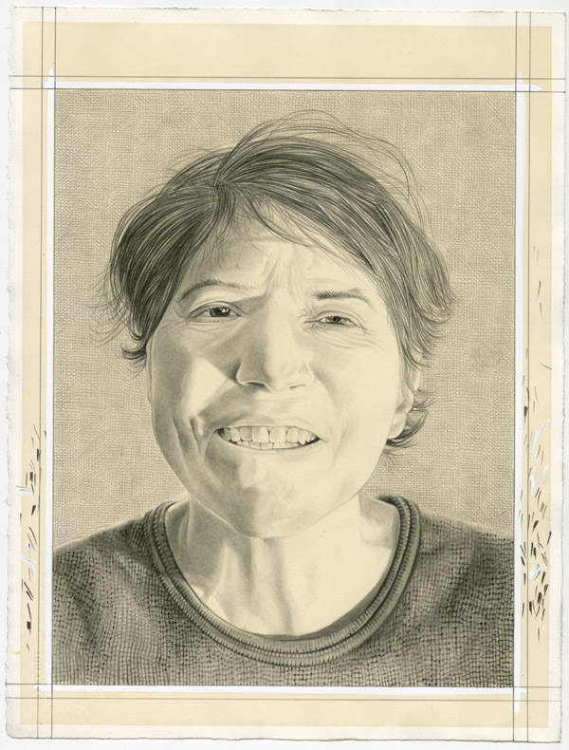

Portrait of Rosalind Krauss. Pencil on paper by Phong Bui. A commissioned drawing for the Brooklyn Rail.

<http://www.brooklynrail.org/2012/02/art/rosalind-krauss-with-yve-alain-bois>